HOME PAGE

YOUR PROPERTY

OUR PRIORTY

Boutique property management with a personal touch—keeping you connected and your investment effortless.

Pioneering Property Management in Auckland
Property Management That Works For You
At Rent Worx, we believe property management is about more than managing a rental — it’s about looking after your property as if it matters to us too.
We provide personal, reliable property management across South and East Auckland, with a simple focus: good tenants, well-maintained properties and clear communication with owners.
We take the time to understand you, your property and what matters to you. We keep things straightforward, stay on top of the details and are always here when you need us.
Our aim is simple — to make property ownership easier, with a property manager you can trust.

Hi can this Service write up go here AS WELL in square blocks

Our Property Management Services

Rent Collection
We manage rent collection and monitor payments closely, helping ensure rent is received on time and keeping you informed of any issues.

Tenant Screening
Finding the right tenant matters. We carry out a thorough application and screening process, including appropriate reference and background checks, to help identify suitable tenants for your property.

Property Inspections
Regular property inspections help us identify maintenance needs early, monitor the condition of your property and keep you informed with clear inspection reports.

Repairs & Maintenance
We work with a trusted network of qualified tradespeople to handle repairs and maintenance promptly and professionally, helping keep your property well maintained.

Property Knowledge
With a strong understanding of the local property market and tenancy requirements, we help ensure your property is managed in line with current regulations and good industry practice.

Property Marketing
We present your property professionally across relevant platforms, arrange viewings and work to attract suitable tenants for your rental.

Methamphetamine Testing
Where required, we can arrange methamphetamine testing to help identify potential contamination and provide greater peace of mind for property owners.

End-of-Year Financial Support
We keep your property management records organised throughout the year, making it easier to access the information you need for your end-of-year accounting and tax requirements.

Tenancy Tribunal Support
If a tenancy matter reaches the Tenancy Tribunal, we can assist with the process and represent you where appropriate, helping you understand the process and protect your interests.

Elevate Your Portfolio
The Rent Worx Difference:
Personal care, proactive updates, and zero stress. We manage the hard work so you can enjoy the returns.

Investor Endorsements

Testimonial

Empowering Auckland Landlords
Local Hands, Loyal Partners for Auckland Landlords
Sharp, proactive management boosting your financial returns

Specialized Landlord Solution
• 1. Proactive Updates:
We keep you perfectly informed, managing flawless communication between you and your tenants.

• 2. Rapid Response:
Tenant requests or owner queries—we handle everything instantly with swift, decisive action.

• 3. Dedicated Bilingual Manager:
You get a personal, dual-language property expert managing your daily operations.
• 4. Maximum Market Yield:
We keep our finger on Auckland's pulse to secure top-tier rental returns and zero vacancies.

• 5. Flawless Financial Management:
Rent collections, invoices, and property expenses are sorted and paid right on time.

• 6. 24/7 Digital Portal:
Track your investments instantly with easy online access to statements, ledgers, and documents.
• 7. Premium Tenant Selection:
We safeguard your property by placing premier tenants through rigorous background and credit vetting.

• 8. Total Maintenance Care:
We coordinate all repairs seamlessly, keeping you informed and getting things done only with your approval.

• 9. Routine Photo Inspections:
We conduct regular property reviews, providing you with detailed photo reports to protect your asset.

• 10. Zero-Headache Operations:
We take the stress and guesswork out of land lording so you can simply enjoy your returns.

11 Healthy Homes Auditing
Continuous compliance oversight ensuring your property meets heating, insulation, ventilation, and moisture ingress laws.

Standard of Excellence

Local Hands. Loyal Partners

We protect your capital and eliminate landlord risk through systematic workflows. From detailed photographic property records and vetted trade maintenance to strict arrears management, we look after your asset like our own.

Landlord FAQs

Do you collect a bond?
Yes. The Residential Tenancies Act requires that no more than four weeks' bond be collected. Unless otherwise agreed, Rent Worx considers three weeks to be the minimum that should be paid. The bond is paid before the tenant takes possession and is held by the Bond Centre until the tenant vacates

How often do you pay Landlord?
We credit your funds directly into your bank account twice a month. To keep your books simple, we email you a comprehensive monthly statement on the first working day of the month, completely detailing all income, expenses, and attached invoice copies.
How much will your service cost me ?
Management Fees From Just 5%
Our property management packages range from 5% to 7% + GST, depending on the size of your portfolio and the level of support you want. We don't believe in one-size-fits-all fees.
Call us today to find out which package fits your investment goals perfectly!

Will I be charged for a vacant property ?
NO

Does Rent Worx guarantee me for any loss of rent ?
NO
How often do you inspect my property ?
We carry out regular property inspections, typically completing four per year unless agreed otherwise before management begins. Please check your insurance policy requirements, as most policies mandate a specific inspection frequency. Share this detail with your property manager, and we will align our schedule to keep you fully covered.
How do you handle missed rent payments?
We monitor rent payments digitally so we can spot a missed payment instantly and start debt recovery immediately. While we do everything we can to resolve issues early, we will escalate the matter to formal mediation or the Tenancy Tribunal if necessary. We do not charge for our time during these processes. You will only need to cover the standard government application fee, which is currently $29.00 including GST

I will be moving overseas- can you handle all repairs ?
Yes. We use a trusted team of skilled, competitively priced tradespeople who prioritize our calls for fast turnarounds. If you have a preferred contractor, we are happy to use them.
Important Note . By law, if you are outside of New Zealand for more than 21 consecutive days, you must appoint a local agent to manage your property

TENANTS

Fostering Great Tenancies
Sustainable property management begins with respect. Rent Worx guarantees clear communication channels, rapid responses to maintenance logs, and properties audited to ensure warm, dry, and compliant living conditions.
Residents benefit from our dedicated emergency support dispatch and transparent online tenancy workflows.

Welcome to Your Next Home
We connect quality residents with safe, compliant, and well-maintained properties built on mutual respect and open communication. With Rent Worx, you get a dedicated team that values your peace of mind.

Why Rent With Us:

- Healthy Homes: Every property is audited to ensure it is warm, dry, and fully compliant.
- Rapid Response: We resolve maintenance logs quickly so your home stays in top shape.
- 24/7 Support: Residents benefit from an emergency dispatch line for urgent issues.
- Simple Processes: Manage your tenancy effortlessly via our transparent online portal.
Our processes are simple, stress-free, and we are always just a phone call away.

Can you please add link or tab of Rent or Book a Viewing

FAQ
TENANT
HOW DO I APPLY ?
An application form is available by clicking here. Note each applicant is subject to a background and credit check.

WHAT ARE YOUR MOVE IN COST ?
On approval, every tenant is required to pay a four week bond and two week's rent in advance, unless stated otherwise in advertising.

HOW OFTEN DO YOU DO INSPECTION ?
We will inspect your home each quarter, unless otherwise stated by the property owner. All inspections and property access is done in accordance with the Residential Tenancies Act.

I WORK FULL TIME, HOW CAN I VIEW PROPERTY
We are available for viewings by appointment to suit.
WHAT NOTICE DO I HAVE TO GIVE TO LEAVE MY TENANCY
If you are on a periodic tenancy, the required notice is 21 days and must be provided in writing. Please note that legal service times apply. A vacate notice template is available in our forms section OR Tenancy Services provides an official template for this exact scenario

I NEED SOMETHING FIXED
Please contact us via email for all non urgent maintenance. For urgent maintenance please call and txt.

Essential Resources
Please add these
Rubbish Collection Days
https://www.aucklandcouncil.govt.nz/en/rubbish-recycling/rubbish-recycling-collections/rubbish-recycling-collection-days.html

Get Connected Easily
https://www.fastconnect.co.nz/applications/apply_now

Rent / Viewing PAGE
AUCKLAND SOUTH AND MORE
I AM ATTACHING SUBURBS
- Alfriston
- Clendon Park
- Conifer Grove
- CLEVEDON
- Drury
- Goodwood Heights
- Hill Park
- Homai
- Manukau
- Manurewa
- Manurewa East
- Papakura
- Papatoetoe
- Randwick Park
- Rosehill
- Takanini
- The Gardens
- Totara Heights
- Wiri
- Wattle Downs
- Weymouth
- Bombay
- Karaka
- Paerata

AUCKLAND EAST AND MORE

- Bucklands Beach
- Cockle Bay
- Eastern Beach
- Farm Cove
- Half Moon Bay
- Howick
- Mellons Bay
- Pakuranga
- Pakuranga Heights
- Shelly Park
- Sunnyhills
- Botany Downs
- Dannemora
- East Tāmaki
- East Tāmaki Heights
- Flat Bush
- Golflinks
- Northpark
- Ormiston
- Somerville
- Beachlands
- Maraetai
- Whitford

RENTAL APPRAISAL
We Handle the Details. You Enjoy the Returns.

Appraisal Request
Please contact our team today if you require an accurate, up-to-date rental assessment in the Auckland region. Ensuring your asset is correctly aligned with the current market is essential for maximizing your overall yields. Furthermore, an official appraisal serves as a vital document to help determine your borrowing capacity and secure investment finance with major banks.
Every custom rental appraisal we generate delivers deep insights into key market drivers:

- Targeted Weekly Returns:
- A realistic estimation of the peak weekly rent your property can realistically command.
- Localized Area Analysis:
- Concrete comparisons showing the performance of similar rental properties nearby.
- Official Baseline Data:
- Verified market statistics detailing lower, median, and upper-tier rents based on bedroom counts.
- Suburban Growth Indicators:
- Comprehensive data regarding your property's unique features, local infrastructure, and neighbourhood amenities.

Please fill out the rental appraisal form below or get in touch if you have any additional questions.

I would prefer wherever possible have information box
FIRST NAME
LAST NAME
MOBILE
EMAIL
ADDRESS

Service

Our Property Management Services

Rent Collection
We manage rent collection and monitor payments closely, helping ensure rent is received on time and keeping you informed of any issues.

Tenant Screening
Finding the right tenant matters. We carry out a thorough application and screening process, including appropriate reference and background checks, to help identify suitable tenants for your property.

Property Inspections
Regular property inspections help us identify maintenance needs early, monitor the condition of your property and keep you informed with clear inspection reports.

Repairs & Maintenance
We work with a trusted network of qualified tradespeople to handle repairs and maintenance promptly and professionally, helping keep your property well maintained.

Property Knowledge
With a strong understanding of the local property market and tenancy requirements, we help ensure your property is managed in line with current regulations and good industry practice.

Property Marketing
We present your property professionally across relevant platforms, arrange viewings and work to attract suitable tenants for your rental.

Methamphetamine Testing
Where required, we can arrange methamphetamine testing to help identify potential contamination and provide greater peace of mind for property owners.

End-of-Year Financial Support
We keep your property management records organised throughout the year, making it easier to access the information you need for your end-of-year accounting and tax requirements.

Tenancy Tribunal Support
If a tenancy matter reaches the Tenancy Tribunal, we can assist with the process and represent you where appropriate, helping you understand the process and protect your interests.

The Rent Worx Story: Dedicated Operational Focus

Led by Rajiv Kumar, Rent Worx was founded on a simple but powerful philosophy: residential property management demands absolute, dedicated operational focus.
A name synonymous with the Auckland real estate industry, Rajiv launched Rent Worx to elevate the standards of traditional property management. We believe that looking after an investment property shouldn't be a sideline service—it requires a boutique team that is entirely all-in.
We protect your portfolio by focusing fiercely on three core pillars:
- Safeguarding Asset Condition: Through rigorous, systemized property reviews and detailed digital photo tracking, we actively preserve the structural and financial value of your property.
- Flawless Healthy Homes Compliance: We navigate evolving New Zealand tenancy laws seamlessly, auditing every asset to ensure total compliance and completely removing legal risk from your shoulders.
- Proactive Landlord Communication: No gaps, no guesswork. We pride ourselves on keeping you thoroughly in the loop with transparent updates and immediate access to your property information.

At Rent Worx, we don't just oversee rentals—we partner with you to make sure your investments genuinely thrive.

Reasons Landlords Choose Rent Worx
Six operational commitments that set our management apart.

• 1. Focused Management: Our focus is entirely on managing rental properties and supporting landlords and tenants.

• 2. Exhaustive Tenant Screening: Complete identity, credit, reference, affordability, and Tenancy Tribunal records checked for every adult applicant.

• 3. Zero-Tolerance Arrears Policy: Automated tracking systems monitor rent payments daily, ensuring immediate intervention and rapid legal notices upon default.

• 4. Photographic Condition Audits: Comprehensive routine inspections delivered directly to your inbox with clear property recommendations.

• 5. Statutory Compliance:
Continuous Healthy Homes standards and Residential Tenancies Act tracking to protect owners from expensive tribunal liabilities.

• 6. Localized Market Expertise: Specialized, on-the-ground property management across South Auckland and East Auckland communities.

I had liked this idea of rentworks web page , see if you can fit this

Upgrade to Rentworx now and experience the difference of client focused property management.
OPTION 1

Organise a rental appraisal.
Whether you are a seasoned investor looking to step back from self management, or you are purchasing your first investment (and everything in between!) Rentworx are here to assist.
​
Contact our friendly team today and we will give you a free, no-obligation rental appraisal on your property.
Book an Appraisal

OPTION 2

Switch over to Rentworx
Changing property managers is a lot easier than you may think! After you give us authority to manage your investment we can contact the previous agency and handle this transfer on your behalf.

Our team will collect all keys and documents as well as work alongside the tenants to ensure it is a smooth transition.

SWITCH TO US

HOMEPAGE PAGE
Ajit, it’s looking nice, especially the moving picture on the home page. Also can you please make QR code for me
Just a few minor corrections:
- In the moving picture, please make the word RENT blue, as it is getting a little camouflaged. Also make PROPERTY MANAGEMENT underneath it blue.
- I noticed “Your Property, Our Property” is written twice. Please remove one.or make it blue (the smaller one)
- Instead of “20 Years in Property Management”, please use “Over 20 Years in Real Estate.”
- For Properties Managed, please use 4+.
- For Happy Clients, please use 8+.
- For Customer Satisfaction, please use 100%.
- Please remove “Average Time to Secure” altogether.
OUR STARTEGIC PILLARS
- Instead of “Audited Accounting”, please just use “Accounting.”
The Rent Worx Difference
- Behind “The Rent Worx Difference”, please use a photo featuring the Auckland Sky Tower.
TESTIMONIALS
- I’m also attaching a few testimonials. I will draft a few more from people I know and send them through.

LANDLORD PAGE

Local Hands, Loyal Partners for Auckland Landlords - Sharp, proactive management boosting your financial returns CAN THIS BE IN BLUE AS WHITE IS NOT GIVING EFFECT OR CAN BE MIX OF BLUE AND YELLOW AS IN LOGO

Specialised Solutions
Comprehensive management ensuring absolute peace of mind.

Please add 1 more in the box
12. Vacancy & Tenant Retention:
We work proactively to minimise vacancy periods and maintain good tenant relationships, helping keep your property occupied and your rental income consistent.

Managing & Protecting Your Investment
Landlord FAQs
Just 1 change in first one
Answer - Our management fee is a percentage of the rent we collect, clearly stated upfront with no hidden extras. It covers tenant screening, rent collection, routine inspections, maintenance coordination, and full compliance oversight. Marketing costs, where applicable, are charged separately. You receive your rent and enjoy peace of mind, hassle-free.

TENANTS PAGE

Why Rent With Us:

24/7 Support- please change this to Support- remove 24/7
Looking for a new home
Browse our active South and East Auckland listings. - can you please change the colour as not much visible on phone
If possible, pick similar photo from NZ, otherwise it good too

Select Auckland City
I the dropdown - Is there a way to keep the suburbs alphabetical order ?

South and more drop down please remove Clendon, Homai from the list and correct Clevedon by mistake its written in CAPS

East and more please add Burswood and correct spelling of Golflink to Golflands

Trade Me Rental Portals
Looking for additional property configurations? Access active Trade Me Auckland listings filtered by room requirements.

I personally think I should remove this as it will take them to my competitors stock , instead once I have my linked portal with Trademe or HouGarden. Or FB page. I will use that link so they are directed to my listing

RENTAL APPRAISAL PAGE

Please fill out the rental appraisal form below PLEASE CHANGE THIS TO
Please Complete the Rental Appraisal Form
AND PLEASE ADD ONE MORE TAB GARAGE and give drop down foe cars 1or 2
Add time when is property available – give them option to write like text

The photo on left side says condition of sale , please change , as cant have word sale.

SERVICE PAGE

Full-spectrum operational and compliance support. NOT VISIBLE PLEASE SELECT BLUE OR YELLOW

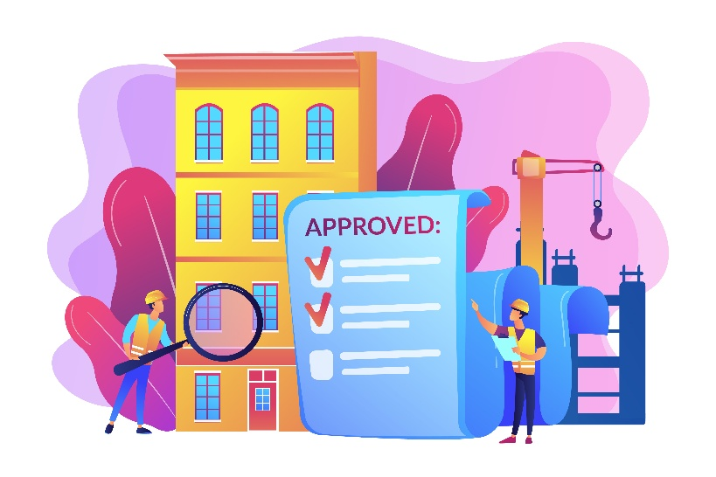
Sorry I didn’t like the pic, can you change it please

ABOUT US PAGE
- Remove 20+ yrs property management instead use Over 20 Years in Real Estate.

Please change my photo to any of these


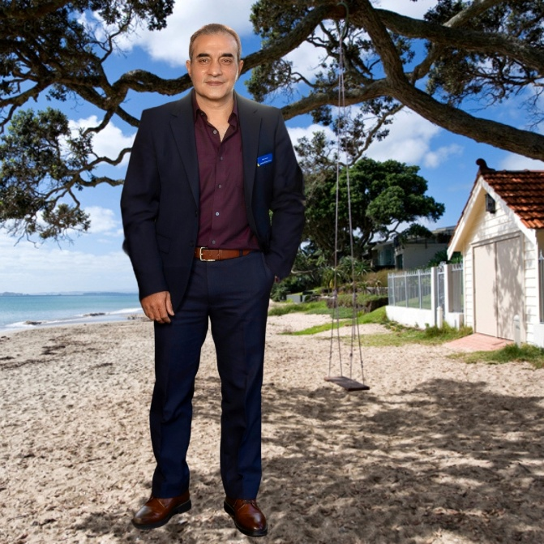

CONTACT US PAGE
Get in Touch
Reach out to Rajiv and the Rent Worx team please try blue and yellow



Can this photo be from nz please

Lastly regarding map are you able to map south Auckland and east Auckland or put pins to show are we serve

